|  |  |  |  |  |  |  |
| --- | --- | --- | --- | --- | --- | --- |
| **name** | **online_order** | **book_table** | **rate** | **votes** | **approx_cost(for two people)** | **listed_in(type)** |
| Jalsa | Yes | Yes | 4.1 | 775 | 800 | Buffet |
| Spice Elephant | Yes | No | 4.1 | 787 | 800 | Buffet |
| San Churro Cafe | Yes | No | 3.8 | 918 | 800 | Buffet |
| Timepass Dinner | Yes | No | 3.8 | 286 | 600 | Buffet |
| Onesta | Yes | Yes | 4.6 | 2556 | 600 | Cafes |
| Penthouse Cafe | Yes | No | 4 | 324 | 700 | other |
| Smacznego | Yes | No | 4.2 | 504 | 550 | Cafes |
| Village CafÃ© | Yes | No | 4.1 | 402 | 500 | Cafes |
| Cafe Shuffle | Yes | Yes | 4.2 | 150 | 600 | Cafes |
| The Coffee Shack | Yes | Yes | 4.2 | 164 | 500 | Cafes |
| San Churro Cafe | Yes | No | 3.8 | 918 | 800 | Cafes |
| Cafe Vivacity | Yes | No | 3.8 | 90 | 650 | Cafes |
| Catch-up-ino | Yes | No | 3.9 | 133 | 800 | Cafes |
| Kirthi's Biryani | Yes | No | 3.8 | 144 | 700 | Cafes |
| oms Restaurant An | Yes | No | 3.1 | 13 | 400 | Cafes |
| The Vintage Cafe | Yes | No | 3 | 62 | 400 | Cafes |
| Woodee Pizza | Yes | No | 3.7 | 180 | 500 | Cafes |
| My Tea House | Yes | No | 3.6 | 62 | 600 | Cafes |
| Coffee Tindi | Yes | No | 3.8 | 75 | 200 | Cafes |
| Redberrys | Yes | No | 4 | 219 | 600 | Cafes |
| Foodiction | Yes | No | 2.8 | 506 | 500 | other |
| Sweet Truth | Yes | No | 3.9 | 35 | 500 | Dining |
| Ovenstory Pizza | Yes | No | 3.9 | 172 | 750 | Dining |
| Faasos | Yes | No | 4.2 | 415 | 500 | other |
| Behrouz Biryani | Yes | No | 3.9 | 230 | 650 | Dining |
| Fast And Fresh | Yes | No | 2.8 | 91 | 400 | Dining |
| Szechuan Dragon | Yes | No | 4.2 | 1647 | 600 | Dining |
| Empire Restaurant | Yes | No | 4.4 | 4884 | 750 | other |
| hi Davangere Benn | Yes | No | 4 | 17 | 150 | Dining |
| Chaatimes | Yes | No | 3.8 | 133 | 200 | Dining |
| McDonald's | Yes | No | 3.9 | 286 | 500 | Dining |
| Domino's Pizza | Yes | No | 3.9 | 540 | 800 | Dining |
| Onesta | Yes | Yes | 4.6 | 2556 | 600 | other |
| Kitchen Garden | Yes | No | 3.6 | 244 | 300 | Dining |
| Recipe | Yes | No | 4 | 804 | 450 | Dining |
| Beijing Bites | Yes | No | 3.7 | 679 | 850 | Dining |
| Tasty Bytes | Yes | No | 3.1 | 245 | 300 | Dining |
| Shree Cool Point | Yes | No | 4.1 | 28 | 150 | Dining |
| Biryanis And More | Yes | No | 4 | 618 | 750 | Dining |
| FreshMenu | Yes | No | 3.9 | 627 | 450 | Dining |
| shankari Donne Bir | Yes | No | 3.8 | 104 | 300 | Dining |
| Wamama | Yes | Yes | 4.2 | 354 | 800 | other |
| XO Belgian Waffle | Yes | No | 3.7 | 17 | 400 | Dining |
| Goa 0 Km | Yes | Yes | 3.6 | 163 | 800 | Dining |
| Chinese Kitchen | Yes | No | 3.8 | 58 | 150 | Dining |
| Kabab Magic | Yes | No | 4.1 | 1720 | 400 | Dining |
| amma Brahmin's Id | Yes | No | 3.6 | 34 | 100 | Dining |
| Burger King | Yes | No | 3.2 | 71 | 600 | Dining |
| The Good Bowl | Yes | No | 3.6 | 6 | 500 | Dining |
| reshwara Davange | Yes | No | 4.1 | 558 | 150 | Dining |
| nna Dum Biriyani C | Yes | No | 3.6 | 28 | 300 | Dining |
| lu Sea Food Restau | Yes | No | 3.8 | 153 | 500 | Dining |
| Frozen Bottle | Yes | No | 4.2 | 146 | 400 | Dining |
| Meghana Foods | Yes | No | 4.4 | 4401 | 600 | Dining |
| Polar Bear | Yes | No | 3.8 | 71 | 400 | Dining |
| ngaluru Coffee Hou | Yes | No | 4.1 | 201 | 300 | Dining |
| Anna Kuteera | Yes | No | 4 | 771 | 450 | Dining |
| Vijayalakshmi | Yes | No | 3.9 | 47 | 200 | Dining |

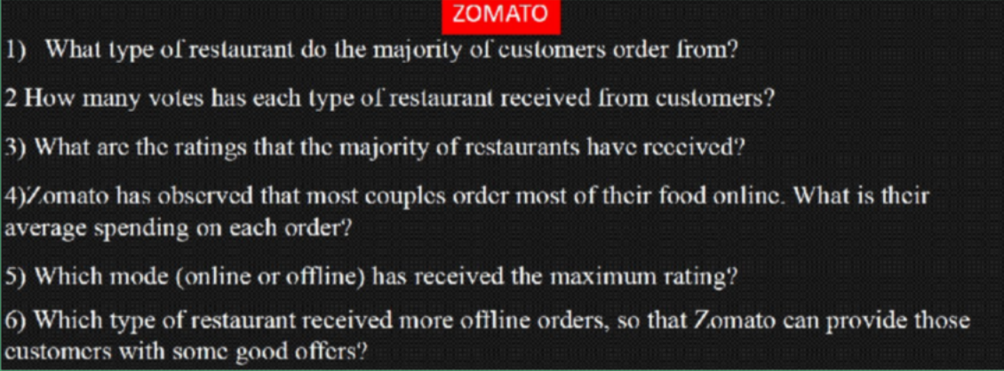

|  |  |
| --- | --- |
| **NO OF RESTAURANTS** | **Count of online_order** |
| Buffet | 7 |
| Cafes | 23 |
| Dining | 110 |
| other | 8 |
| **Grand Total** | **148** |

**ORDERS VS RESTAURANTS**

7 8

Buffet Cafes Dining other

Grand Total

23

110

148

It is clearly seen that most of the customers prefer the Dining restaurant

|  |  |
| --- | --- |
| **TYPE OF RESTAURANTS** | **Sum of votes** |
| Buffet | 3028 |
| Cafes | 6434 |
| Dining | 20363 |
| other | 9367 |
| **Grand Total** | **39192** |

**RESTAURANTS VS NO OF VOTES**

**3028**

BUFFET CAFES DINING OTHER GRAND

TOTAL

**6434**

**9367**

**20363**

**39192**

The Dining restaurant has most number of votes amongst all restaurants

**DISTRIBUTION OF RATINGS**

**76**

**46.2 40.8**

**39.6 55.5**

**2.6 5.6**

**6**

**21.7 22.4**

**21**

**39 40 45.1 33.6**

**4.3 8.8 9.2**

**20.3**

**537.7**

|  |  |
| --- | --- |
| **RATINGS** | **Sum of rate** |
| 2.6 | 2.6 |
| 2.8 | 5.6 |
| 2.9 | 20.3 |
| 3 | 6 |
| 3.1 | 21.7 |
| 3.2 | 22.4 |
| 3.3 | 46.2 |
| 3.4 | 40.8 |
| 3.5 | 21 |
| 3.6 | 39.6 |
| 3.7 | 55.5 |
| 3.8 | 76 |
| 3.9 | 39 |
| 4 | 40 |
| 4.1 | 45.1 |
| 4.2 | 33.6 |
| 4.3 | 4.3 |
| 4.4 | 8.8 |
| 4.6 | 9.2 |
| **Grand Total** | **537.7** |

MOST OF THE RATINGS RECEIVED BY THE RESTAURANTS ARE 3.7 AND 3.8



Grand Total

950

900

850

800

750

700

650

600

550

500

450

400

350

300

250

200

150

100

0

20 40 60 80 100 120 140 160

**APPROX COST FOR COUPLES**

APPROX COST FOR MOST COUPLES IS 300

|  |  |
| --- | --- |
| **APPROX COST** | **Count of approx_cost(for two people)** |
| 100 | 6 |
| 150 | 16 |
| 200 | 16 |
| 250 | 6 |
| 300 | 23 |
| 350 | 3 |
| 400 | 15 |
| 450 | 6 |
| 500 | 14 |
| 550 | 3 |
| 600 | 13 |
| 650 | 2 |
| 700 | 5 |
| 750 | 3 |
| 800 | 12 |
| 850 | 2 |
| 900 | 2 |
| 950 | 1 |
| **Grand Total** | **148** |



100

90

80

70

60

50

40

30

20

10

0

ONLINE(YES)

MODE OF ORDER OFFLINE(NO)

HIGHEST RATING FOR MODE OF ORDER

**2.6**

**2.8**

**2.9**

**3**

**3.1**

**3.2**

**3.3**

**3.4**

**3.5**

**3.6**

**3.7**

**3.8**

**3.9**

**4**

**4.1**

**4.2**

**4.3**

**4.4**

**4.6**

**GRAND TOTAL**

|  |  |  |  |
| --- | --- | --- | --- |
| **Count of rate MODE OF ORDER** | | | |
| **RATINGS** | **OFFLINE(NO)** | **ONLINE(YES)** | **Grand Total** |
| 2.6 | 1 |  | 1 |
| 2.8 |  | 2 | 2 |
| 2.9 | 7 |  | 7 |
| 3 | 1 | 1 | 2 |
| 3.1 | 5 | 2 | 7 |
| 3.2 | 6 | 1 | 7 |
| 3.3 | 14 |  | 14 |
| 3.4 | 12 |  | 12 |
| 3.5 | 6 |  | 6 |
| 3.6 | 5 | 6 | 11 |
| 3.7 | 12 | 3 | 15 |
| 3.8 | 9 | 11 | 20 |
| 3.9 | 2 | 8 | 10 |
| 4 | 4 | 6 | 10 |
| 4.1 | 4 | 7 | 11 |
| 4.2 | 1 | 7 | 8 |
| 4.3 | 1 |  | 1 |
| 4.4 |  | 2 | 2 |
| 4.6 |  | 2 | 2 |
| **Grand Total** | **90** | **58** | **148** |

CLEARLY SEEN THAT THE ONLINE ORDER HAS THE HIGHEST RATINGS AS COMPARED TO OFFLINE

HERE ONLINE DENOTES "YES" AND OFFLINE DENOTES "NO"

|  |  |  |
| --- | --- | --- |
| **Count of online_order** | **MODE OF ORDER** | |
| **RESTAURANTS** | **OFFLINE(NO)** | **Grand Total** |
| Buffet | 3 | 3 |
| Cafes | 8 | 8 |
| Dining | 77 | 77 |
| other | 2 | 2 |
| **Grand Total** | **90** | **90** |



**OFFLINE MODE VS RESTAURANTS**

3

8

90

77

2

Buffet Cafes Dining other Grand Total

DINING RESTAURANT HAS RECEIVED THE MORE NO OF OFFLINE ORDERS